Benefits of using Ferroferon

Iron is a constituent of the red pigments haemoglobin in blood and myoglobin in muscle.
Haemoglobin is responsible for the transfer of oxygen to all cells in the body and supporting cellular metabolism. Iron is a fundamental element for normal development of the immune system. Its deficiency affects the capacity to have an adequate immune response when challenged by disease. Piglets are born with limited iron reserves and require a readily available source of iron within the first 3 days of life.
Therefore iron is vital for the piglet, BUT importantly, not all injectable iron compositions are the same:
Ferroferon contains GLEPTOFERRON

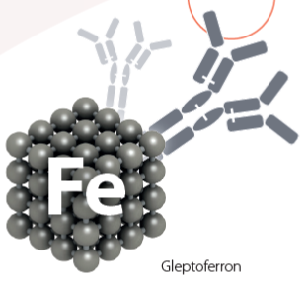

The absorption of gleptoferron is complete and almost immediate. Over 95% of the injected gleptoferron within FERROFERON is taken up within 24 hours, ensuring very high utilisation of the dose by the piglet with no staining at the injection site.
Outperforms other Iron injections containing Iron Dextran and provides higher levels of haemoglobin.

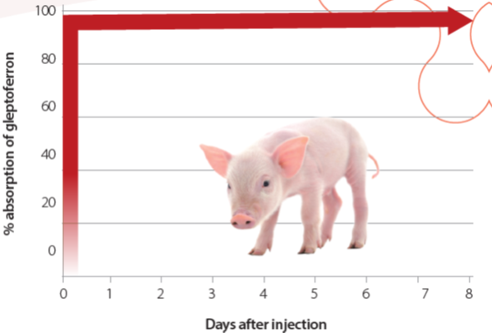

FERROFERON product features
- Can be used on first day of life
- Based on the gleptoferron molecule: maximum and rapid bioavailability.
- Absorption: 95% within 24 hours.
- No ham staining.
- No risk of accumulation of iron at the injection site.
- Highest blood iron levels.
- High growth rates.
- Reduced economic losses at slaughter.

